بسم الله الرحمن الرحيم
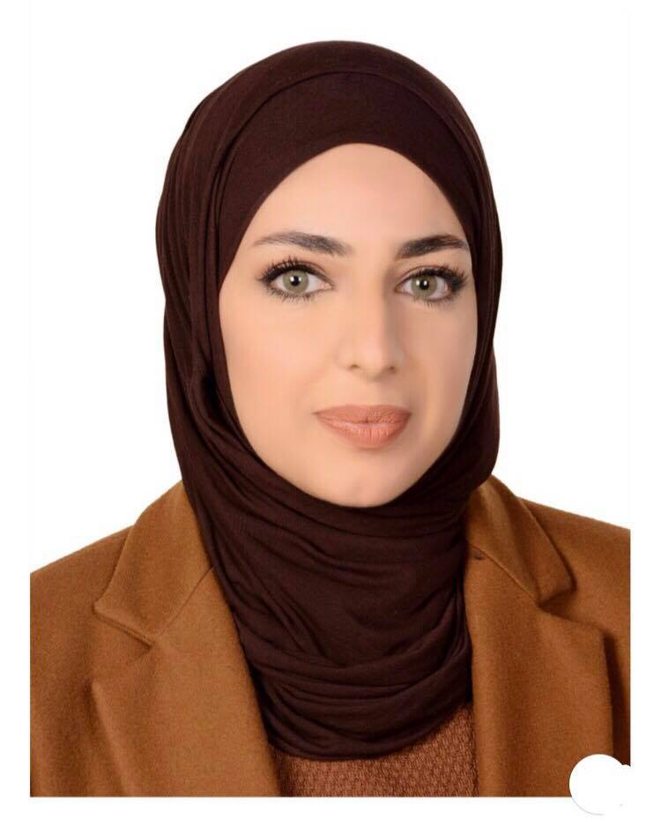
Curriculum Vitae

Personal Information’s:

Name: Suaad Faris
Marital Status: single
Birth Date: 1993\3\30
Place of Birth: Baghdad Iraq
Nationality: iraqi

------------------------------------------------------------------------------------------------------------------

Educational Qualifications:

1. July 2015 : B.Sc., Degree in Law with Very Good grade from ALRashid University College.
2. July 2011 : Baccalaureate in Scientific Section Diploma of high School
3. July 2008 : Certificate of intermediate School
4. July 2005: Certificate of Primary School
5. Certificate from the Cambridge Training College Britain

Other Qualifications:

- Certificate from the University of Baghdad: English skills for Graduate Studies in Iraq.
- Certificate from the University of Baghdad: Computer use for Graduate Studies in Iraq

------------------------------------------------------------------------------------------------------------------

Experience Acquired:

1) 2015-2017 Legal Experience for Practicing Law

2) 2017-2018 work in smadent company

------------------------------------------------------------------------------------------------------------------

Personal Skills:

I'm interested in Travelling, Playing Soccer, Basketball, and Video games, and Community services and social media .

Contacts:

Mobile No. : +96407716134760

E-Mail : faten749@yahoo.com

------------------------------------------------------------------------------------------------------------------

LANGUAGES:

1. Native Language: Arabic
2. fluency : English, Writing and Speaking

